1. ­­­­Vervoer is teleportatie krachten
2. Alles gaat open dicht aan uit door je eigen krachten
3. Er is maar 1 (god) die sommige mensen aanbidden en sommige mensen ertegen werken
4. Gewoon normaal voedsel dat je kan krijgen door het zelf te maken of te kopen
5. Er lopen door de hele wereld verschillende monsters rond die je aanvallen
6. De avonturiers gebruiken hun krachten, zwaarden, guns
7. De normale mensen hebben zelf ook een aantal normale krachten
8. Er zijn grote wezens die je stad/jou aanvallen en je kan sommige om hulp vragen
9. Er zijn bijzondere dieren die je aanvallen of heel rustig rond lopen sommige kunnen je helpen met je avontuur
10. Er zijn verschillende stammen die elk een andere relatie hebben met de andere stammen
11. Je koopt dingen met geld of je ruilt items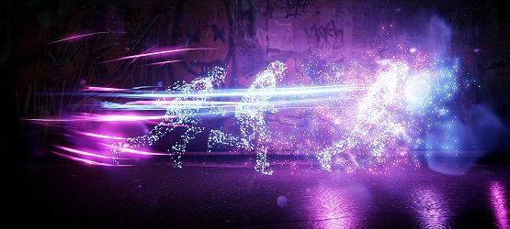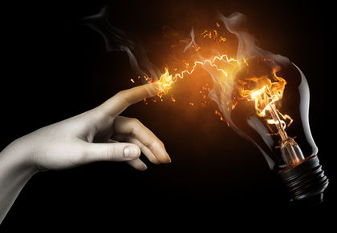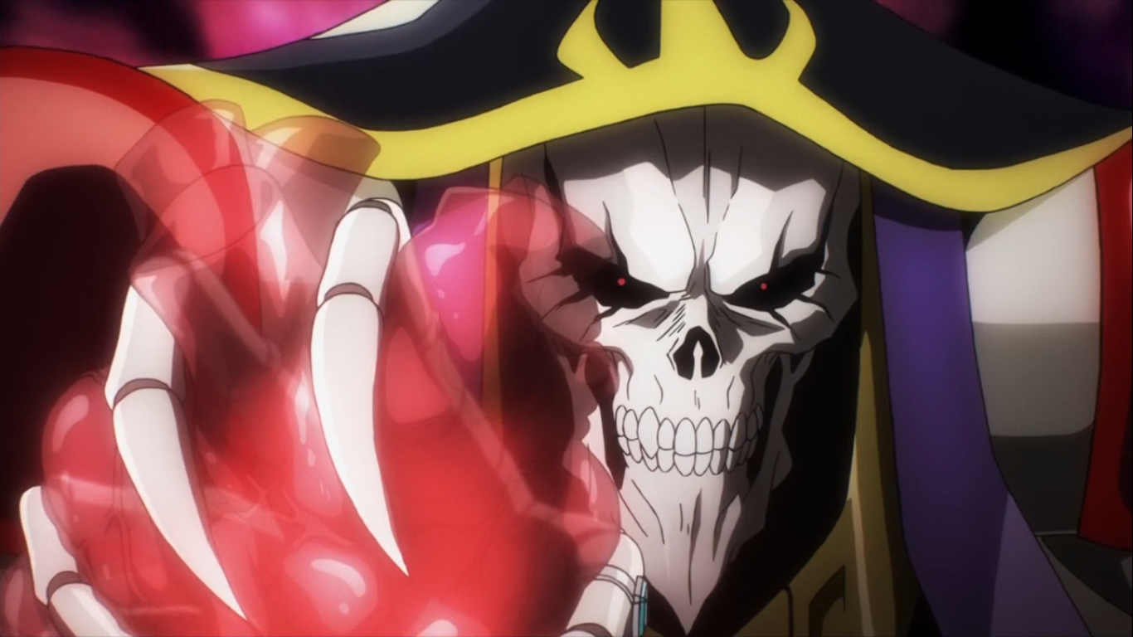

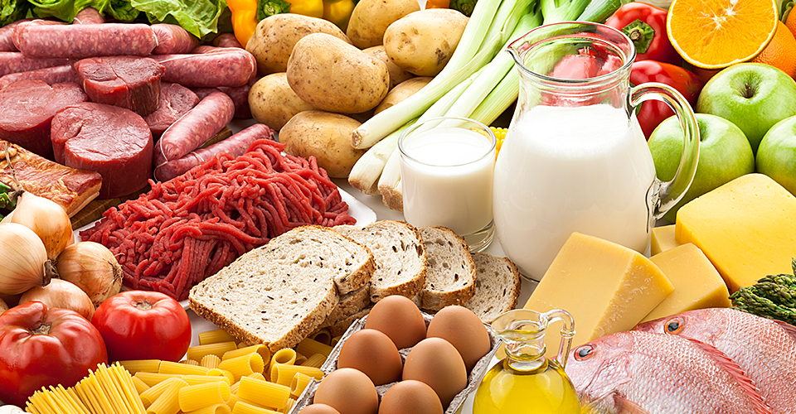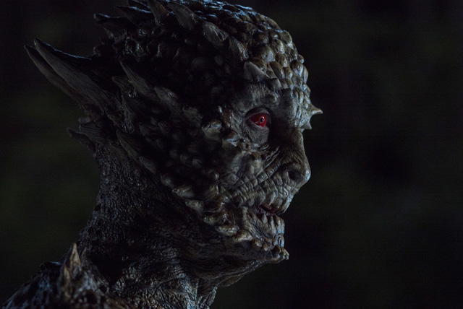

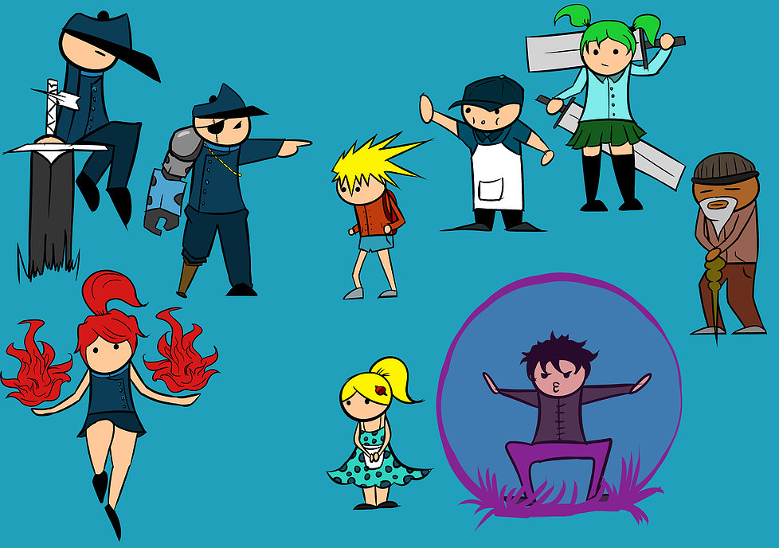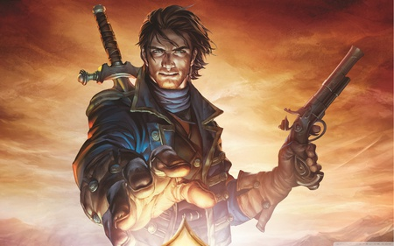

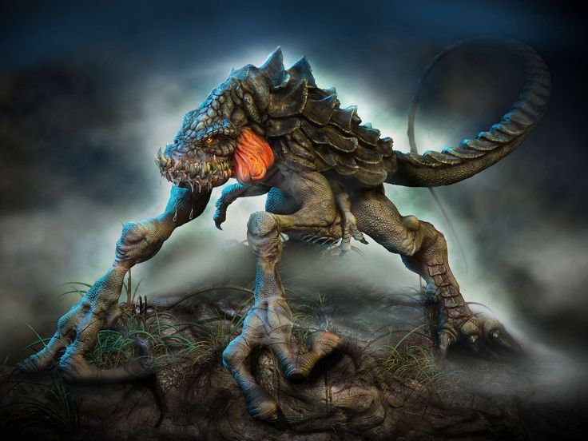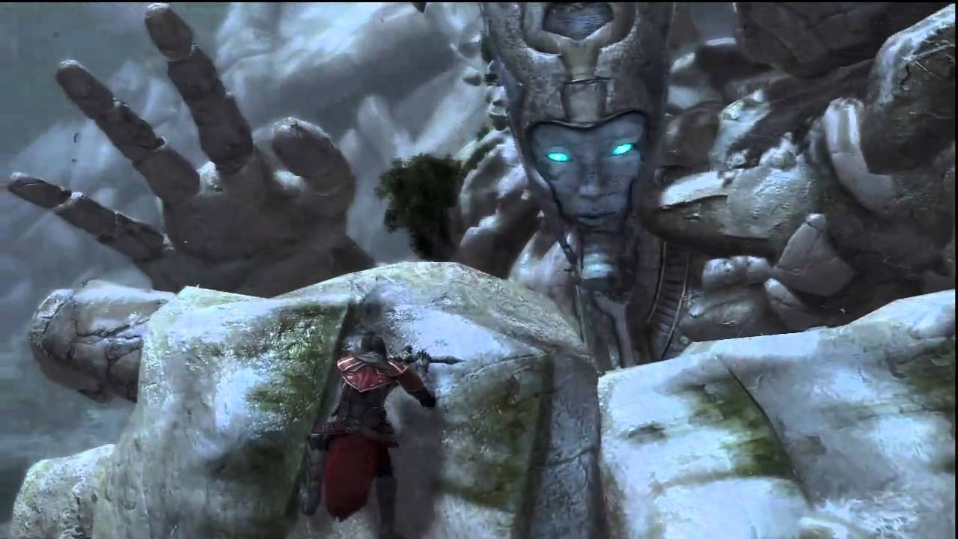

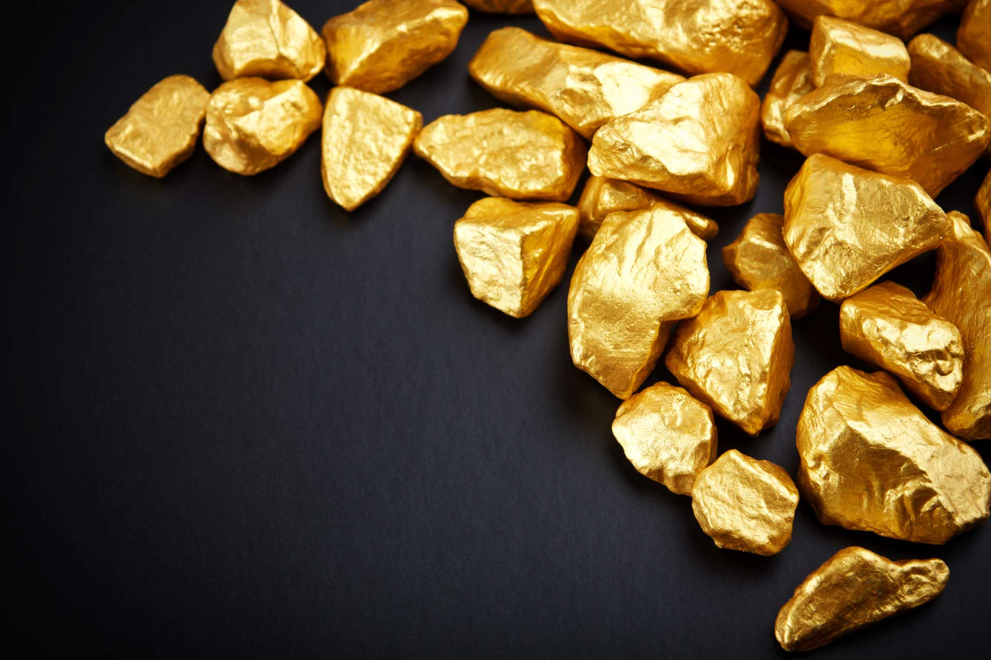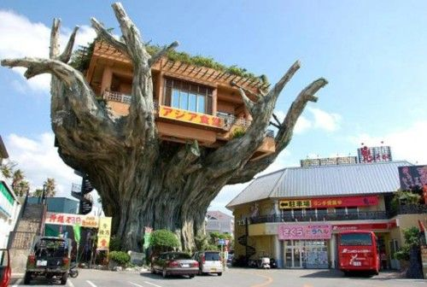

1. Geographic Location
2. In the year
3. In this dystopian society… (Write one sentence that expresses the heart of the story, the conflict as it relates to the dystopia.)
4. What current issue/problem is at the heart of this dystopia?  From what spark of our modern reality was this world born?
5. How does the setting of this story impact the main character?
6. What are the non-negotiable rules of this world?   Are there any exceptions?
7. What laws does society impose?  What happens to people who break them?
8. What rules or laws does the main character break or challenge?  Why?  What are the consequences?
9. What kind of government is in place?  Consider local & national levels as well as international cooperation. How does government impact citizens’ everyday lives?
10. What official document is in place to define that government? If it is a future version of a current document (i.e.Constitution), how has it changed? What amendments have been added?
11. What rights do people have?  What rights are they denied, and why?
12. What are this society’s most closely held values?
13. What social ladders exist? Who has power and why? What are the tangible symbols of that power? Who is at the bottom of this society’s social ladder, and why?
14. What kind of ethnic diversity exists?
15. What role, if any, does religion play in this society? What are the dominant religions? What religions are marginalized?
16. What do international/inter-group relations look like? What wars are going on?  What countries or groups are fighting, and why? Which ones are allies? Which are enemies?
17. What climate and weather patterns are prevalent?
18. What does agriculture look like? Where do people get food?
19. What foods are considered standard fare? What foods are delicacies, and why?
20. What are the energy sources?
21. What are the primary exports and imports of the society?
22. What does the transportation look like
23. How do people communicate and share news?
24. Almost like our world but different
25. It’s in 2016 but it doesn’t really matter much in what year it is
26. In this dystopian society some people don’t like how “the one/leader/ruler/god” is doing.
27. Everyone fears “the one”
28. Create different challenges, missions, possibilities, relationships, thoughts
29. There is normal gravity, the time periods are the same as the real life in some places it’s totally switched so there is no gravity and the periods of time are different.
30. The laws are that you must believe/trust in the “one” if not the people that are is going to make you believe or die.
31. He/she breaks the rule to not believe in the “one”
32. It got ruled by “the one” there is not a national cooperation because it’s one big world. Most people do what “the one” wants
33. Because “the one” is so powerfull everyone feared him so he decided to rule by himself
34. The rights are: you can love/marry anyone you want, you’re not allowed to say bad things about the “one”
35. ?
36. ?, the “one” because he is the strongest of all, ?, the people that don’t believe in the “one”
37. ?
38. There are no religions
39. Some groups are believing in the “one” other groups don’t and some don’t have a side, every group is against each other because they want the oth­­­­ers to believe/don’t believe/loves fighting
40. The weather is the same as the normal world so snow/storm/rain/sun/tornado/tsunami
41. Some people are farming then they sell the food so others can buy them, kill, harvest from animals
42. The food is about the same as our own world
43. Your own powers

­­­­­­­

1. Food, money, materials, weapons
2. You use your own powers and some animals/creatures
3. Like newspaper, radio, television